Process design and digitalisation

Recap from Zara case study
- Process mapping is important to see how long processes will take and help us identify bottlenecks which inhibit further efficiency increases.
  - Lyttle’s law helps us understand the behaviour of processes.
- Importance of delayed differentiation model used by Zara, links to mass customisation which we explore here.

Variation – enemy of productivity
Variation can occur in product quality, quantity, and timing.

Variation in quality
- Variation in quality leads to internal and external failure, due to reputation effects, warrantee costs and return costs.
- Variation in quality also kills productivity as it soaks up capacity and destroys predictability, which makes it hard to plan

Variation in quantity
- Variability in demand affects variation in quantity needed.

Variation in timing
Timing – processing time. Post office example, segregating users whose requests have different processing times.

Buffers
- Buffers smooth the effects of variation on the firm’s ability to match supply to demand.
- Can occur in the form of time, inventory or capacity
  - Time
  - Inventory is our end product. We bear the cost of holding inventory, so these storage costs must be balanced against the benefits of being more able to match supply to demand.
  - Excess capacity allows short lead times. Emergency services – time and inventory can’t be buffers, so we hold excess capacity of ambulances and fire engines so we can match supply to demand. Here, inventory is the patient or fire.
- What are the types of variation and what type of buffer can avoid a supply-demand mismatch?

The art of process
- All processes exhibit variation. Firms can seek to eliminate variation and standardise, or instead customise and personalise the process
  - Mass processes include manufacturing of ammunition
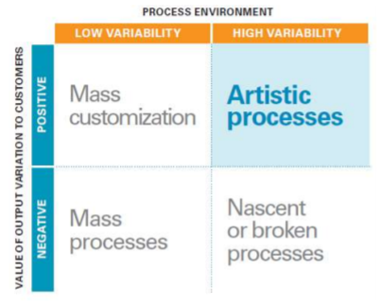
  - Mass customisation example is Nike ID. Catalogue customisation, restricted.
  - Artistic processes or deep customisation is MyAdidas

Customer induced variability
- Customer determines whether variability is valuable.
  - Arrival variability
  - Request variability e.g., travellers requesting a room with a view
  - Capability of engagement in operations. Customers have different skill levels, for example some are unable to explain symptoms to a doctor
  - Willingness to engage in their role e.g., putting carts back at ASDA
  - Subjective preferences affect perceptions of quality service
- Service providers can reduce customer variability, reducing their choice (thus customer service) to improve operational efficiency.
  - For example, set restaurant menus, requiring appointments and reservations etc.
- Alternatively, service provides can accommodate customer variability, which increases value added and improves customer services, at the expense of operational efficiency.
  - For example, requiring slack time and experienced employees.

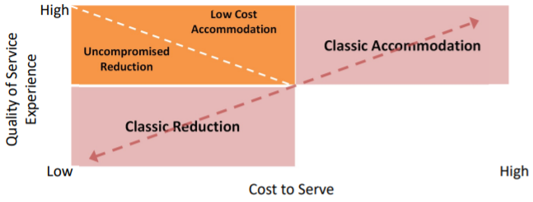
Variability – reduce or accommodate?
- Uncompromised reduction: admit specific customer groups of lower variation i.e., by similar requests, capability, motivation, subjective preferences
- Low-cost accommodation: let customers serve themselves through automated tasks. Ryanair could reduce variation through fines, these are instrumental incentives. Normative incentives are those appealing to emotions, such as Zipcar.

Process types
- Manufacturing processes form a spectrum from high variety low volume, to low variety, high volume. In this order, they are projects, job shops, batch production, line production, continuous processing.
  - Organised in a diagonal from top left to top right

Project
- The project is the epitome of customisation as the entire production design and delivery processes are geared to delivering a single, unique product.
  - Resources used are generic in nature, operated by highly specialised workers.
  - Equipment used for projects tend to be general purpose so that it can be reused for the next project
  - The workforce needs to be highly skilled and respected in their respective tasks as they need to execute a wide range of diverse tasks based on the specific order
- Key operational challenge: lower-level repetition can prevent the identification of problems and therefore the ability to codify practices
- Loch et al distinguishes between different projects based on the complexity of the project and the degree of uncertainty facing the project team
  - Uncertainty can be in the form of known unknowns (normal variance due to different contextual circumstances) and unknown unknowns

Job shops
- Job shops create a wide variety of products in significant quantities. Job shops’ layout groups similar equipment together (“process centres”), because no single product generates enough sales volume to justify the creation of a product-specific array of equipment. A job shop typically contains a diverse array of equipment with different capabilities.
  - Examples include machine shops, kitchens and plastic molding operations
- The routing of material through a job shop can be complex and multi-directional. With each order/job capable of such flexibility, it is essential that information on the order’s routing through the factory, and the work to be done at each stage, follows the job.
  - A well-functioning job shop is heavily dependent on its information flows
  - Job shops typically bid for work, so need accurate information on costs, routings, and process steps, in order to bid intelligently and schedule effectively.

Batch flow processes
- Batch flow processes have much in common with job shops, with similar layouts and equipment groups by function rather than by product. The product moves from department to department, with the operation depending on information such as routings and process steps, tracking costs and times.
- However, batch flow processes typically have a set menu of products they produce and in set quantities (lot sizes). Thus, they are more standardised than the job shop
- Batch production is not always associated with smaller lot sizes than line flow and continuous processes; sometimes batch production is the only technically feasible method i.e., brewing beer, producing vaccines, fermenting cheese

Line flow processes (mass processes)
- Line flow processes lie closer to continuous flows than batch flows. It is exemplified by moving assembly lines found in the auto industry.
- Line flow processes exhibit a product-specific layout with different pieces of equipment placed in sequence ready to operate on the product. The product moves from one operation to another so there is little work-in-progress inventory. This increases the need to “balance” the process so that the different tasks take roughly the same amount of time to accomplish
- Paperwork is less demanding the batch flow or job shop because routings are not needed, and products have set recipes that remove the need for tracking labour and machine inputs to particular products.
- Line flow is more flexible than continuous flow, less automated and more labour intensive

Continuous flow processes
- Higher volume and lower variety than line flow processes

Hybrid processes

- McKinsey would do batch systems, industry analysis then customise to the firm

Manufacturing digitalisation
- Increasing connectivity through globalisation increases consumer demand for personalisation, with a Deloitte report detailing the premium some consumers are willing to pay if they have an active role in design. Digital manufacturing could provide multiple ways to satisfy these needs, through affecting the way manufacturing operations are conducted.
- Fourth industrial revolution is based on the application of digital technologies and can be termed Smart Factory or digital manufacturing. These technological advancements have altered the trade-off between variety and volume in manufacturing processes.
  - 3D printing avoids the traditional trade-offs between customisation and volume, thus allowing high customisation at a lower cost. This is because of the economies of scale achieved, and the maximised capacity utilisation rate vs specialist machinery. Higher capacity utilisation rate will also allow a shorter payback period.
  - Here, the cost of complexity becomes zero, and we avoid path dependency in our processes.
- Digitalization of manufacturing enables us to move away from the product-process diagonal. Further examples include:
  - Cybersecurity
  - Digital twin: a simulated version of a product which through multi-physics simulations and machine learning can show to workers the impact of various environmental and product changes. This reduces the cost of customisation by eliminating the need for physical prototypes and by allowing predictive maintenance to reduce actual maintenance costs.

Extra reading

Hayes and Wheelwright (1979)

Introduction
- Emphasis of product life cycle upon marketing can make it inadequate for strategic planners
- This piece shows how the process life cycle can inform manufacturing choices; using the concept of a product-process matrix, they show how a company's position reflects its weaknesses and strengths, and they discuss the implications for corporate strategy.
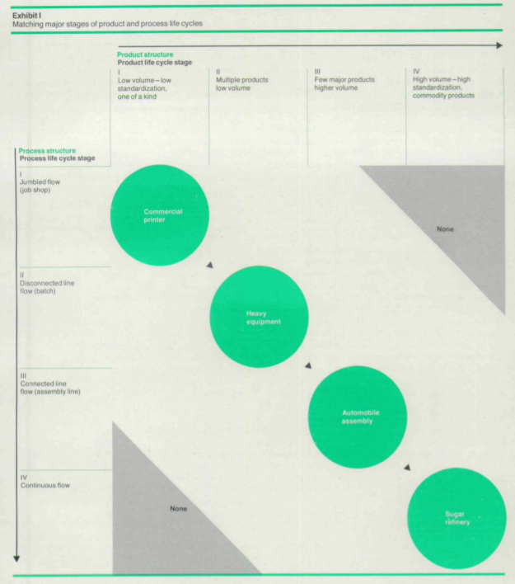
- Separating the product life cycle from a phenomenon termed the process life cycle facilitates an understanding of the strategic options available to a country wrt to manufacturing function.

Product-process matrix
- Just as a product and market pass through a series of major stages, so does the production process used in the manufacture of that product.
- The process evolution typically begins with a "fluid" process—one that is highly flexible, but not very cost efficient—and proceeds toward increasing standardization, mechanization, and automation.
- This evolution culminates in a "systemic process" that is very efficient but much more capital intensive, interrelated, and hence less flexible than the original fluid process
- Rows in matrix show the stages the production process goes through, from fluid to systemic. Columns show the product life cycle

Diagonal position
- A company occupies a particular region in the matrix. Commercial printer in the top left;
- Each job is unique and a jumbled flow or job shop process is normally the most effective in meeting those product requirements. In such a job shop, jobs arrive in different forms and require different tasks, thus equipment tends to be general purpose.
- That equipment also rarely hits a 100% capacity utilisation, workers have a wide range of production skills, and each job takes longer to go through the plant than the labour hours required for the job.
- Further down the diagonal, the manufacturer of heavy equipment usually chooses a production structure characterized as a "disconnected line flow" process.
  - Although the company may make several products, economies of scale in manufacturing usually lead such companies to offer several basic models with a variety of options.
  - This enables manufacturing to move from a job shop to a flow pattern in which batches of a given model proceed irregularly through a series of workstations.
- Down in the far right-hand comer of the matrix, we find refinery operations, such as oil or sugar processing, where the product is a commodity, and the process is continuous.
  - Although such operations are highly specialized, inflexible, and capital intensive, their disadvantages are more than offset by the low variable costs arising from a high volume passing through a standardized process

Off the diagonal
- These examples are the standard set of cases, in which a product structure is matched to its “natural” process structure. However, a company may seek a position “off the diagonal” to gain a competitive advantage.
- For example, Rolls-Royce still makes a limited product line of motor cars using a process more like a job shop than an assembly line.
  - However, firms who unintentionally drift of this diagonal may struggle, such as companies in the factory housing industry who in the 1970s allowed their manufacturing operations to become too capital intensive and too dependant on stable, high-volume production.
  - Moving away from the diagonal makes a company more dissimilar from its competitors. This may make it more vulnerable to attack, depending on its success in achieving and exploiting the advantages of its niche.
  - Co-ordinating manufacturing and marketing could be more difficult as the two areas face different opportunities and threats
- An example of a firm matching its movements on the two dimensions with changes in its industry is Zenith Radio in the mid-1960s.

Applying the concept
- 3 issues stemming from product-process life cycle: idea of distinctive competence, management implications of selecting a specific product-process combination and the organising of units to specialise on separate portions of the manufacturing process, whilst maintaining overall co-ordination.

Distinctive competence
- Most companies see themselves as have competitive advantages in some areas and avoid competition in others. They try to guard this distinctive competence against outside attack.
- Sometimes managers are too focused on marketing concerns and lose sight of manufacturing concerns. Here, the firm is thinking about strategy in terms only of the product and market dimension in the product life cycle context.
- Instead, the firm should keep a two-dimensional focus, allowing it to concentrate its attentions on a restricted set of process decisions and alternatives, AS WELL AS a restricted set of marketing alternatives. Real focus is therefore maintained on a single “patch” in the matrix – a process focus, as well as a product/market focus.
- Thinking about both process and product dimensions can affect the way a company defines its “product”, and hence where it places itself on the diagonal and hence which projects and decisions are supportive of the firm’s true position on the matrix

Effects of position
- Management problems change with different combinations of product and process

When should a process be art (Hall, J. and Johnson, E 2009)
- Some processes naturally resist definition and standardisation – understanding which should not be standardised, and how to manage scientific v artistic processes is what this article answers.
  - 3 step approach to identifying artistic approaches and successfully integrating them into the business.
  - Scientific and artistic processes should be harmonised, not at odds.

What is an artistic process?
- Common thread is variability in the process, its inputs and its outputs. Art needed in changeable environments – when consumers value unique output and raw materials aren’t uniform and require a craftsman’s adjustment.
  - If only one or neither condition is present, use mass or mass customisation
- Highly variable environment – sometimes costs of decreasing variability outweigh the benefits e.g. cookbook approach to complex diseases
  - Trying to tame a highly variable environment by introducing complex rules for every scenario reduces accountability and encourages autopilot working
  - Ritz-Carlton reduced from a 20-point checklist to 12 values which aided judgement and guided improvisation – necessary because of younger guests who were more tech savvy and diverse
- Output variation creates customer value. In these highly erratic environments, output variation is natural and can be beneficial to the customer. Artistic processes are required where there is no consistent definition of quality (distinct pianos).
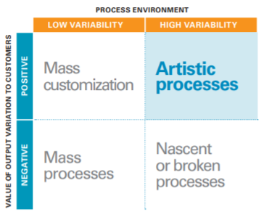
  - Artistic processes can capably and reliably produces innovative products which scientific processes cannot mimic e.g. scripted greetings.

How to manage artistic processes
3-step approach to developing and supporting artistic processes:
- Identify what should and should not be art using the process matrix. If a process is nascent, determine whether it should move toward a mass or artistic process.
  - Don’t discount the possibility that customers can be persuaded to value variations
- Develop an infrastructure to support art – ensure artists have freedom to refine their art, and the freedom to create maximum customer value.
  - Create appropriate metrics. Internally focused metrics for consistency will not work – artists rely on external measures (customer feedback)
  - Get art and science to work together. Managers should separate them and carefully manage areas where they intersect. If one process is being asked to perform art and science, it should be divided.
  - Build an effective training programme to allow artists to learn the skills of their trade. Formal apprenticeship and informal mentoring.
  - Tolerate failure – variations make it impossible to satisfy every customer on the first time. Companies may need extensive quality inspections to prevent failures affecting customers e.g. Ritz Carlton empowers employees to spend $2,000 to fix a customer’s problem.
    - If failures were rare, the process is predictable enough to be turned into a science
- Periodically re-evaluate the division between art and science – changing customer needs and technologies can make art more or less desirable. What new tech can make science of art?
  - Sometimes we also realise art simply produces better results, hence the shift from the rules based Generally Accepted Accounting Principles to the International Financial Reporting Standards, a simpler set of principles allow auditors to exercise more judgement.
- Invest in giving employees skills, judgement, and cultural appreciation to excel in variable conditions

100 years down the line (Vlasic, 2013)
- Comparing Fordism to modern day production
- In the beginning, the line was a critical step toward ensuring that the same processes were repeated over and over to manufacture one specific model of the highest quality. Now, the modern assembly line produces a wide variety of vehicles that are virtually custom-built at a moment’s notice for customers in far-flung markets.
- It also uses three-dimensional drawings to create prototypes of components that can be tested in days rather than months.
- On the line, new robotic systems used in the final assembly process can detect even the tiniest specks of dirt and prevent imperfections in paint that mar the surface of a sparkling new car.
- Michigan assembly plant: recently added production of the new C-Max Hybrid — a smallish wagon that shares many parts with the Focus but has an entirely different shape and style.
  - Want to replicate this - within the next five years, our plants globally will be able to produce an average of four different models or derivatives of a model
  - “What is facing the customer needs to be different, and what is not facing the customer can be the same,” Mr. Ammann said.
- Today’s car buyers expect new features in their vehicles: navigation devices, Internet connections, collision-avoidance systems, hybrid power from a combination of gasoline engines and batteries.
  - Auto executives and engineers are constantly reacting to those demands and developing new technology to satisfy them. Yet it still comes down to the assembly line to integrate the latest features seamlessly into the final product.

Inside the digital factory (Geissbauer et al)
- Critical planning, scheduling, warehousing, inventory management, and logistics processes have been automated and simplified.
- AI, big data, and robotics, combined with the cloud, is creating totally integrated factories that can rapidly tailor products to individual customer needs and respond instantly to shifting demands and trends.
  - improved control and visibility throughout the supply chain
- Digital factory is an end-to-end ecosystem. This ecosystem includes internal functions — for instance, sales, procurement, engineering, and R&D — and external players, including suppliers and customers.

Digitisation and customisation
- The possibility of being able to immediately tailor products to match customer preferences and to offer customers the option to “build” their own products appears to be driving production decisions more strongly than slashing labour costs.
  - 80 percent are looking at Western Europe (where their largest customer bases are) for new digital factory capacity.
- Adidas’s new “speed factories” have automated production lines, managed by human programmers and fed by networks that oversee the supply chain. These are able to make a pair of expensive, customized cross-trainers from start to finish in about five hours. In Adidas’s low-cost, less digital Asian factories, this process can take several weeks.
  - According to the company, the speed factories will more than pay for themselves in the next few years when they are scaled up.
  - They are expected to slash the long lead time for debuting new shoe designs and allow Adidas to react quickly to changes in customer preferences.

Modernising technology
- Drones can be used for rapid transport and visual surveillance of equipment performance. Austrian automotive supplier Magna Steyr employs drones in its plant, to independently fly through the assembly line, scanning materials labels to compare against available stock in the warehouse and provide information to the network for managing factory inventory.
- The digital twin s a virtual doppelganger of the plant, including form and processes. With this approach, new factories can be designed and engineered in 3d, and potential inefficiencies may be remedied before the plant is put into service. After the plant is on-line, real-world data is fed back into the digital twin, which can be monitored and adjusted to continuously optimize processes and maintain equipment at peak efficiency.

Obstacles to digital factories
- Advanced production approach represents an entirely new model of human–machine interaction.
- Understanding the impact on the people in the company is at least as important as calculating the financial benefit of the digital factory, in part because the former will ultimately impinge on the latter.
  - Employees who feel marginalized by the emphasis on new technologies will compromise the factory’s chances for success.
  - Around half of manufacturers believe that their employees are not open to digital change, and an equal proportion feel that their company lacks a truly digital culture.
- Solutions can be bottom-up, i.e. companies retraining their able workers to be more data orientated, or top-down, through government apprenticeships and training schemes to forge workers better matching the skill requirements of digital factories

Implications
- There also may be ways to monetize the data generated by the manufacturing process itself. The implications of this are profound. With a digital factory, instead of focusing solely or primarily on production, some companies may have opportunities to increase profit margins and customer share in the lucrative after-sales market as well as tap entirely new business sectors.
- it is likely that the return on investment for a digital factory could take as long as five years. This increases the urgency for manufacturers to begin developing digital factories; consider the competitive position your company will be in if it is the last to realize that the factory of the future has arrived.

FT Article (Pooler, 2017)
- Cobots work alongside humans and have been spreading across production lines. They are typically smaller, flexible, and mobile, and cheaper than their heavy-duty cousins.
- They are also slower, but cobots are highly adaptable and can be assigned to different tasks. This is because cobots learn by imitation using vision recognition software. This means programming a cobot to do a new task is much quicker than programming larger industrial robots
- Cobots can improve health and safety conditions for humans by performing repetitive tasks that require uncomfortable or dangerous movements

Additive manufacturing
- 3d printing, involves building objects layer by layer out of substrates. Prototyping has long been a popular application, as 3D printing enables rapid iterations of a design.
- It is increasingly being used for final production as costs fall and speed increases. The global market in products and services for additive manufacturing increased 17.4 per cent to $6.1bn in 2016, according to Wohlers Associates.
  - About 60% of that spending was linked to production applications, up from about half the year before
- Key industries include aerospace and healthcare, with additive manufacturing the norm in dental devices and hearing aids.

Digital twin
- Virtual model of a product process or service described as a bridge between the real and digital world. Data from sensors on physical equipment are streamed to the virtual representation to create a constant loop.
- Saves money on prototypes. Also extends to factory floors, enabling the simulation of machinery before anything is built. In the past, production lines had to be switched off to prepare for a new product being made, so downtime can be avoided in this manner
- One key limitation of the adoption of digital twins is that it is hard to scale digital twins to more heavily customised products because of their different configurations and equipment use from different suppliers

Supply chain tracking
- Our capabilities of tracking items sent from suppliers throughout all stages of the supply chain are becoming enhanced to rises in computing power
- Logistics systems used to track at the ship or truck level, but now trackers and sensors can be placed on individual pallets and products.
- Data from these sensors can be processed by computers to reveal information on the goods, such as current location in transit or journey path, temperature, humidity, vibrations etc. This data can be measured, reported and analysed to understand their effect on product quality.
  - Connected freight systems can make automatic corrections e.g. if a lorry driver turns off the refrigeration system whilst in traffic, or alternatively can send out message to operators when human intervention is possible

GE (Zaleski, 2015)
- Bestselling aircraft engine ever produced by GE will be the first to use 3-d printed fuel nozzles.
  - Each Leap engine contains 19 nozzles: where 20 parts were machined together for the nozzle, there is now only one piece built up by layering powered metals which are melted and fused together through a DMLM process
  - This makes each nozzle 5x stronger than those made through welding and other subtractive manufacturing processes

GE website – additive manufacturing
- Allows engineers to simultaneously design improvements in product performance, reliability, cost and weight, all at faster speeds.
  - GE Aviation’s Advanced Turboprop engine – 855 subtractive parts reduced to 12 uniquely complex additive manufactured parts, saving weight, cost and improving performance.
- 2016 – set up a new business selling additive machines and powders.

